Amazon Web Services
Simple Queue Service (SQS)
Amazon SQS (Simple Queue Service) is a fully managed message queuing service that lets different parts of an application communicate using messages. It stores messages temporarily and delivers them to consumers reliably, even if systems are slow or offline. SQS helps decouple applications so they run independently without failing together. It is commonly used for background processing, task queues, and distributed systems.
Screenshot1 - SQS Queue Overview
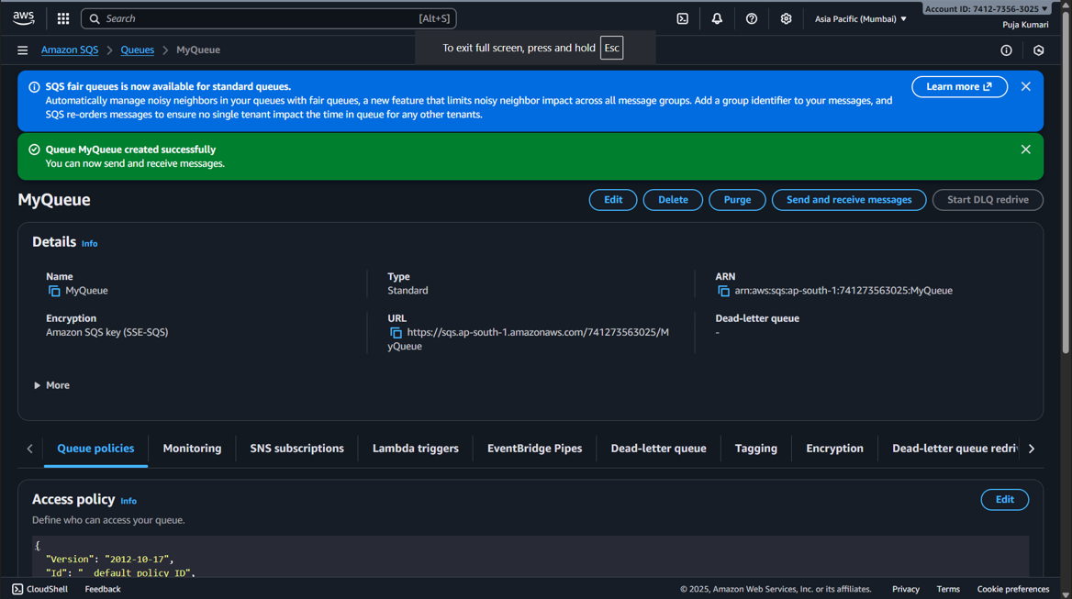
Explaination:
- This screen shows the overview page of our SQS queue named MyQueue, confirming it was created successfully.
- It displays key details such as Queue Type (Standard), Queue URL, ARN, and Encryption settings (SSE-SQS).
- From here, we can Edit, Delete, Purge, or Send and receive messages for this queue.
- The lower section shows the Queue Access Policy, which controls who is allowed to use or access this SQS queue.

Screenshot2 - Receiving Messages
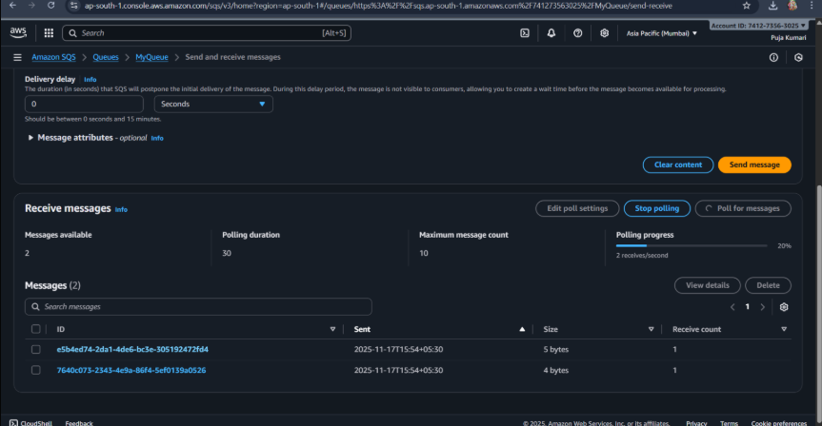
Explaination:
- This screen shows the Amazon SQS queue named MyQueue where messages are being sent and received.
- It displays 2 available messages, along with polling settings and message details like ID, size, and receive count.
- The messages listed below were retrieved during polling and are ready to be viewed or deleted.
- Buttons like Send message, Poll for messages, and Stop polling control the flow of message retrieval.
Screenshot3 - Viewing a Message in SQS
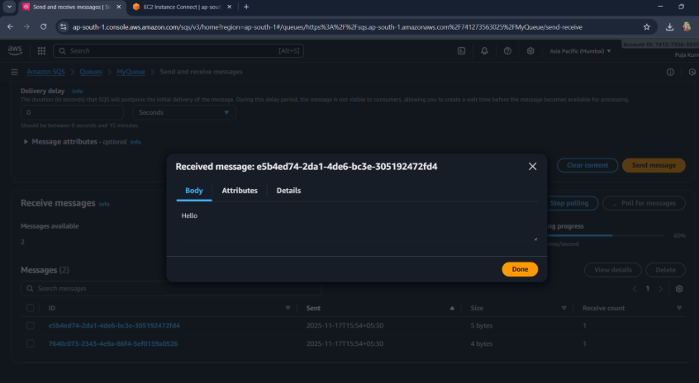
Explaination:-
- This screen shows the content of a specific message retrieved from the SQS queue.
- The message body contains the text “Hello”, which is the actual payload sent to the queue.
- Tabs like Body, Attributes, and Details allow us to inspect different parts of the message.
- The message preview confirms that SQS has successfully stored and delivered the message.

